Nathan Gaffney

10-December-2014

CST-183-FA110-14FA-COURSE

This program will generate a random integer based on the user’s provided range.

Start

Int random

Int minimum

Int maximum

Create the applet

Make panels for each of the fields

Arrange those panels in a grid panel

Then take the text from the first field for a minimum value

The second text field will be the maximum value

Pass those values to a random generator

End

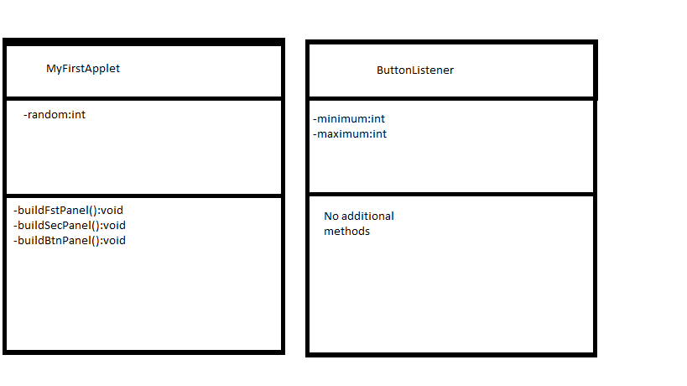

Step 3.

/\*Created by: Nathan Gaffney  
CST 183 Java  
Assignment12  
This will create an applet that wll generate a random integer.  
Exceptions Handled: None  
Dependencies: None  
Methods:  
buildfstPanel  
buildSecPanel  
buildBtnPanel  
randInt  
\*/  
import javax.swing.\*;  
import java.awt.\*;  
import java.awt.event.\*;  
import java.applet.Applet;  
import java.util.Random;  
  
public class MyFirstApplet extends JApplet  
{  
 private Panel fstPanel;  
 private Panel secPanel;  
 private Panel btnPanel;  
 private TextField txtMinimum;  
 private TextField txtMaximum;  
 private Label label;  
 private int random;  
 public void init()  
 {  
 buildFstPanel();  
 buildSecPanel();  
 buildBtnPanel();  
   
 setLayout(new GridLayout(3, 1));  
   
 add(fstPanel);  
 add(secPanel);  
 add(btnPanel);  
 }  
 /\*\*  
 Build the panel to hold the first number  
 \*/  
 private void buildFstPanel()  
 {  
 fstPanel = new Panel();  
   
 Label message1 =   
 new Label("Enter the minimum integer: ");  
 txtMinimum = new TextField(10);  
   
 fstPanel.setLayout(new FlowLayout(FlowLayout.RIGHT));  
 fstPanel.add(message1);  
 fstPanel.add(txtMinimum);  
 }  
 /\*\*  
 Build a panel to hold the second number  
 \*/  
 private void buildSecPanel()  
 {  
 secPanel = new Panel();  
   
 Label message2 =   
 new Label("Enter the maximum integer: ");  
 txtMaximum = new TextField(10);  
   
 fstPanel.setLayout(new FlowLayout(FlowLayout.RIGHT));  
 fstPanel.add(message2);  
 fstPanel.add(txtMaximum);  
 }  
 private void buildBtnPanel()  
 {  
 // Create the panel.  
 btnPanel = new Panel();  
  
 // Create a button  
 Button genButton = new Button("Generate Random Integer");  
  
 // Add an action listener to the button.  
 genButton.addActionListener(new ButtonListener());  
  
 // Add the button to the panel.  
 btnPanel.setLayout(new FlowLayout(FlowLayout.RIGHT));  
 btnPanel.add(genButton);  
 label = new Label("Output");  
 btnPanel.add(label);  
 }  
 /\*\*  
 This method will implement the action listener  
 \*/  
 private class ButtonListener implements ActionListener  
 {  
 public void actionPerformed(ActionEvent e)  
 {  
 int minimum, maximum;   
 minimum = Integer.parseInt(txtMinimum.getText());  
 maximum = Integer.parseInt(txtMaximum.getText());  
 random = randInt(minimum, maximum);  
 label.setText(String.valueOf(random));  
 }  
 }  
 /\*\*  
 This method will generate a random integer.  
 \*/  
 public int randInt(int min, int max)   
 {  
  
 Random rand = new Random();  
 int randomNum = rand.nextInt((max - min) + 1) + min;  
  
 return randomNum;  
 }  
}

Output:

